Science
In Science we will learn about plants. We will learn to name and label the parts of plants and trees. Then we will investigate the types of trees and plants we have on the school grounds. In Autumn 2, we will observe seasonal changes.

Math’s
In Math’s we will be following the Power Math’s scheme which the children will be familiar with. Children learn fluency and mastery of numbers. Our focus: Place value and numbers within 100, being able to read and write these as well as knowing number bonds.

Physical Education
This term the children will be learning about multi-skills and gymnastics.

English
In English this term we will begin by practicing general sentence structures. We will use these skills to develop our writing around a range of high-quality texts.
We will then link closely to our topic by writing a recount of a walk around our local area.


Here I am!
Music
In Music we will be learning to sing expressively and creatively. We will also explore rhythm and pulse as we listen to the music.

PSHE
In PSHE we are learning about ‘Being me in our world’. The children will get to know themselves and each other and find how they fit into our amazing world. We will discuss their incredible stories and families and why there are different kinds of families.

History
In History we will learn that this is a subject in which we learn about the past. We will discover our own family history and explore the generations of people who belong in our families.

Geography
In Geography we will learn about our local area, locating West Park and Plymouth on a map. We will walk around our local environment and discuss West Parks history as well as Plymouth as a whole and our wonderful city.

Religion and Worldviews
To begin we will explore how people show they belong to religious groups.
We will discuss groups that we belong to. In Autumn 2 will explore how Christians celebrate Christmas.

Computing
In Computing we will learn how to keep safe online and the importance of internet safety. We will cover this in the first term as the children will have access to an iPad throughout the year and we want them to remain safe both in school and at home.
Art & DT
In DT, they children will develop their claw and bridge techniques when chopping up ingredients to make a healthy salad. In art, the children will explore and create abstract drawings and paint them using primary colours.

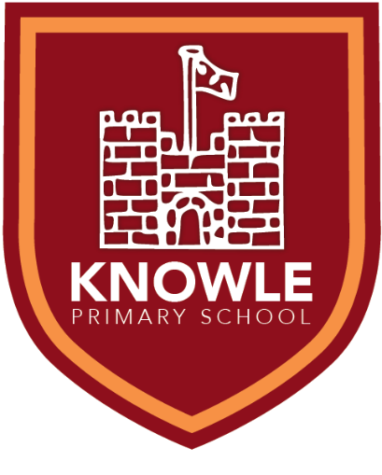

Knowle Primary School Topic Overview
Parent Information for Year 1/2
Autumn Term 2025/26

Key information for this term:

Term Dates:
Start: Tuesday 2nd September
End: Friday 24th October
Start: Tuesday 4th November
End: Friday 19th December (1:30pm)

Trips: Open Top Bus Tour
Tuesday 23rd September 2025
(Parton and Armstrong)
Wednesday 24th September 2025. (Picasso and Armstrong)
Information regarding the Anning class split will be shared in due course.

Local Walk: Date TBC

PE:
Parton class: Tuesday
Picasso class: Wednesday
Armstrong class: Thursday
How can I help at home?
• read with your child daily
• support with home learning each week
• support with learning the different times tables and spellings
• encourage them to share their learning with other family members
• provide a full PE kit to include black shorts, house t-shirt, school hoodie and trainers
• encourage children to log in themselves to TTRS and Numbots. Enabling them to navigate their way around an iPad and log in to different programs will support them with quizzing on their books, computing and practicing their times tables and number fluency.

