Science
In Science we will learn about objects and their purpose, naming the material that they are made from. We will explore a range of materials and describe their physical properties.

Math’s
In Math’s we will be following the Power Math’s scheme which the children will be familiar with. Children learn fluency and mastery of numbers. Our focus: Place value and numbers within 100, length and height, weight and volume and fractions.

Physical Education
This term the children will be developing skills in throwing and catching, balance and dance.
dance in gymnastics.

English
In English this term we will begin by learning the features of journey stories. in preparation to write our own narratives.
We will then link closely to our topic by writing instructions to tell people how to use public transport. Our poetry unit will be inspired by the alphabet.

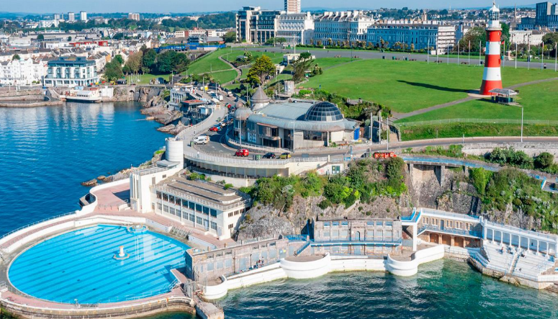
Where We Are!
Music
In Music we will be learning to handle instruments with control. We will create graphic notations to represent sounds as we perform our own sea soundscapes.

PSHE
In PSHE we are learning about ‘Dreams and Goals’ and ‘Healthy Me’. We will link to our core value of ‘ambition’ as we set goals for the future and plan how to achieve them. The children will also learn how to keep their bodies and minds healthy.

History
In History we will learn about the history of transport, including cars, trains, aeroplanes and rockets. Children will learn about significant individuals such as Neil Armstrong, Bessie Coleman and Henry Ford.

Geography
In Geography we will learn about the countries and capital cities of the United Kingdom. They will also learn about the features of rural, urban and coastal areas within the United Kingdom.

Religion and Worldviews
To begin we will explore Christian and Jewish values by exploring the creation story. In Autumn 2 will explore what questions the creation story might make us want to ask.

Computing
In Computing we will continue to learn how to keep safe online and the importance of online identity. We will cover this in PSHE frequently. The children will also develop the skills to create animated stories.
Art & DT
In DT, the children will research lever and slider mechanisms ready to design, make and evaluate their own moving picture. In art, the children will explore and create 3D paper sculptures inspired by the artist Charlie McGee.

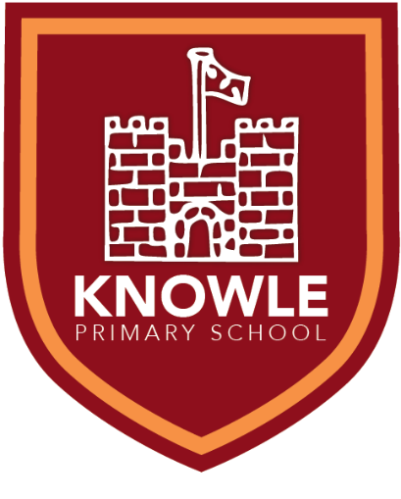

Knowle Primary School
Topic Overview
Parent Information for Year 1/2
Spring Term 2025/26

Key information for this term:

Term Dates:
Start: Tuesday 6th January
End: Friday 13th February
Start: Monday 23rd February
End: Thursday 2nd April

Events:
Clubs Begin: Monday 12th Jan
Fluoride application (optional): Wednesday 21st Jan
NSPCC Number Day: Friday 6th Feb
Valentine Disco: Thursday 12th Feb

PE:
Parton class: Tuesday
Picasso class: Wednesday
Armstrong class: Thursday
How can I help at home?
• Read with your child daily.
• Support with home learning each week.
• Support with learning the different times tables and spellings.
• Encourage them to share their learning with other family members.
• Provide a full PE kit to include black shorts, house t-shirt, school hoodie and trainers.
• Encourage children to log in themselves to TTRS and Numbots. Enabling them to navigate their way around an iPad and log in to different programs will support them with quizzing on their books, computing and practicing their times tables and number fluency.

